**Christmas Food- Ingredients List**

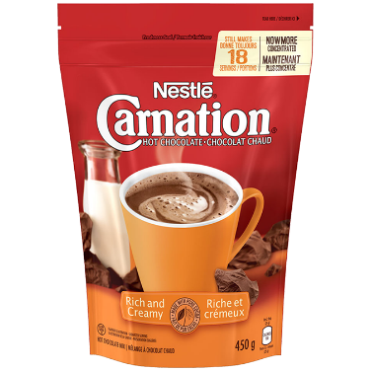

## Carnation Hot Chocolate Rich And Creamy Ingredients

Sugar,Modified Milk Ingredients,Glucose Solids,Hydrogenated Coconut, Palm Kernel and Soy Oils, Cocoa, Salt, Cellulose Gum, Flavour And Artificial Flavour

Dipotassium Phosphate, Mono- And Diglycerides, Datem, Silicon Dioxide, Guar Gum.

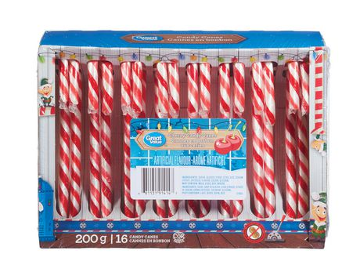Great Value Cherry Candy Canes

Sugar, Glucose Syrup, Citric Acid, Sodium Citrate, Artificial Flavour, Colour, Glycerin, Palm Oil, Canola Oil, Sunflower Lecithin.



Compliments Candy Canes

Sucrose, glucose syrup, natural flavour, colour (contains tartrazine), palm oil, canola oil, sunflower lecithin, glycerin.