**Halloween Candies**

**Jolly Ranchers Dubble Bubble Gum**

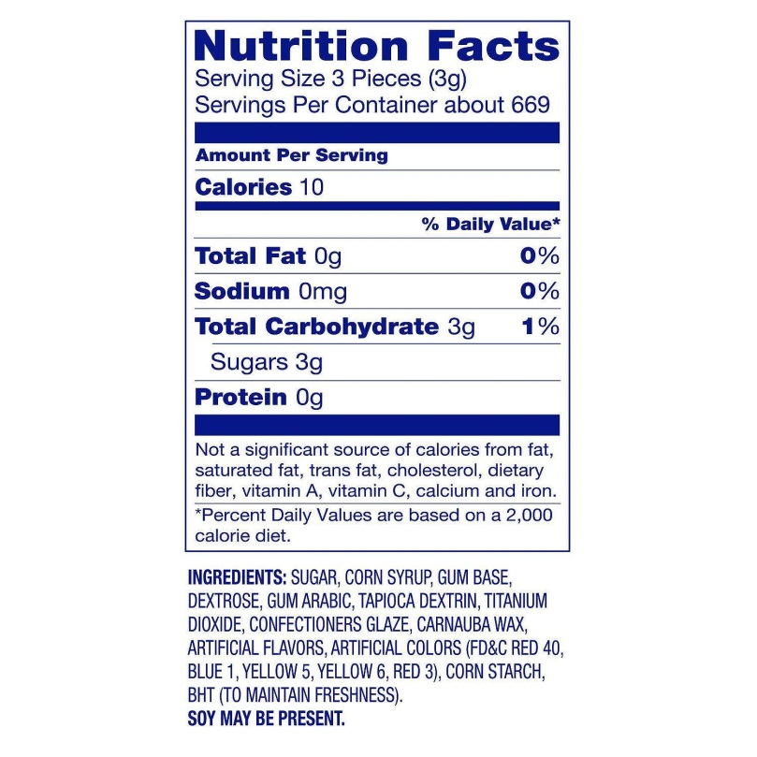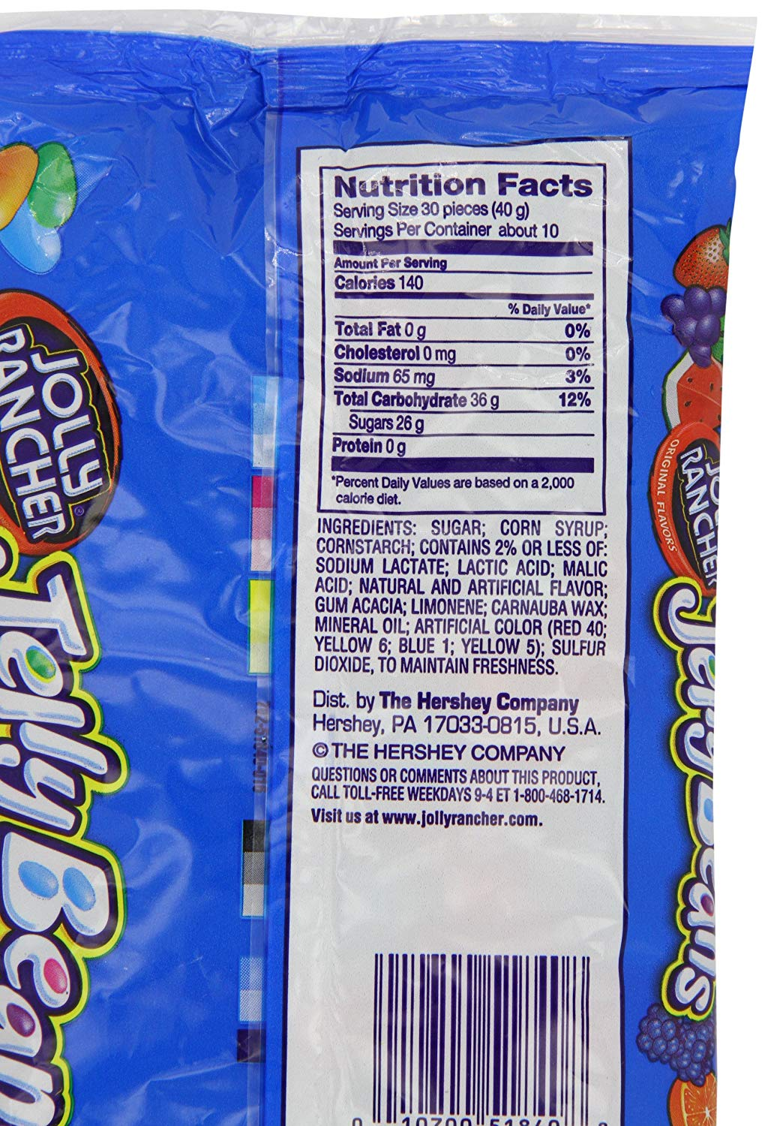

**Pumkin Milk Chocolates**

**Ingredients:** Sugar, cocoa butter, milk, chocolate, soy lecithin (an emulsifier), vanilla.  
  
**Allergen Information:** CONTAINS: MILK, SOY

[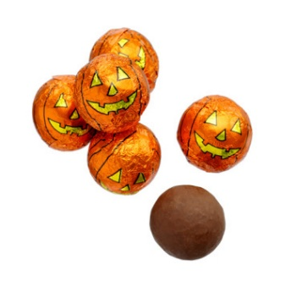](https://www.google.ca/url?sa=i&rct=j&q=&esrc=s&source=images&cd=&cad=rja&uact=8&ved=2ahUKEwiZ6O6_nKzeAhUi3IMKHctWDGAQjRx6BAgBEAU&url=https://www.naturalcandystore.com/product/milk-chocolate-pumpkin-balls/all-products&psig=AOvVaw1geqKCKE1NvLHYUyXhlPrS&ust=1540922155396271)

**Kerr’s Assorted Lollypops**

**INGREDIENTS:** Sugar, corn syrup, citric acid, colours (contains tartrazine), orange oil, natural and artificial flavours.



**Chocolate Caramels**

**Ingredients list:**

Sugar, corn syrup, water, vegetable oil shortening (hydrogenated soybean oil and/or palm oil, canola oil), modified milk ingredients, whole milk, cream, salt, natural and artificial flavor, soy lecithin, mono & diglycerides.

**Substances or products causing allergies or intolerances:** [MILK](https://world.openfoodfacts.org/allergen/milk)

