**Autism Awareness Week Ingredients List**

1. 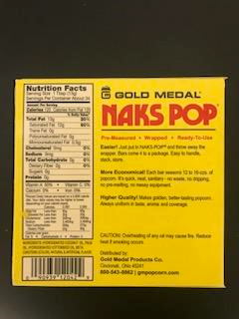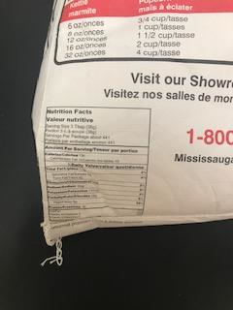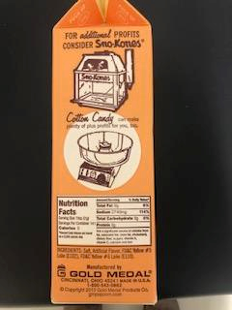Pop Corn:
2. Krispy Kreme Doughnuts:

<http://kkd-nutritional-panels.s3.amazonaws.com/2018OriginalGlazedDoughnutRetailPanel.pdf>