**Spirit Week Ingredients List**

1. 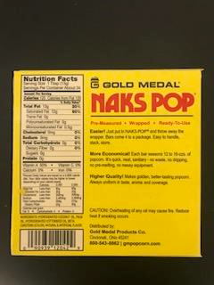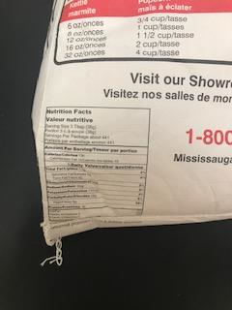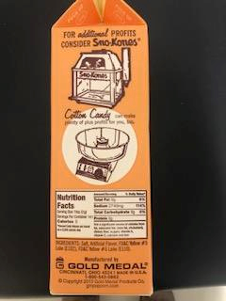Pop Corn:
2. 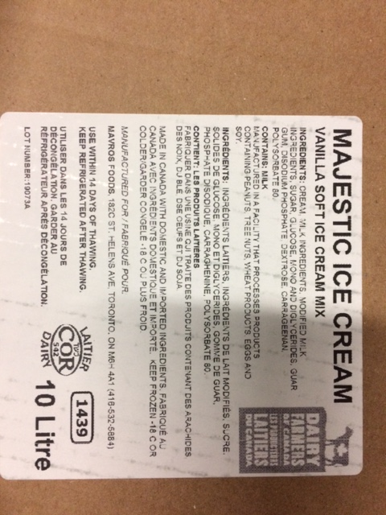Ice Cream

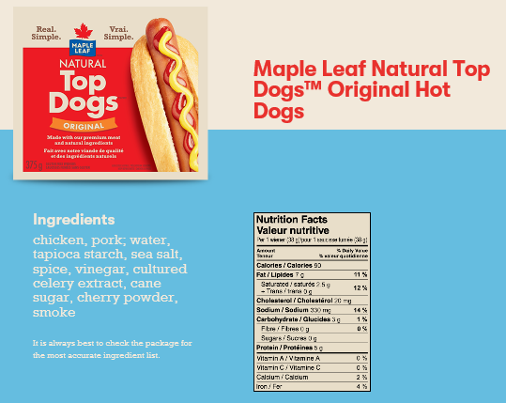

1. Hot Dogs

* **Ketchup** (tomato paste (made from fresh ripe tomatoes), liquid sugar, white vinegar, salt, onion powder, spices.allergens: no.)
* **Relish** (pickled gherkins (gherkin (38%), water, spirit vinegar, salt), sugar, water, onions (5%), spirit vinegar, modified maize starch, acidity regulator (acetic acid), dried red pepper, yellow mustard seeds, ground turmeric, ground cloves.)
* **Mustard** (distilled vinegar, water, #1 grade mustard seed, salt, turmeric, paprika, spice, natural flavors and garlic powder)

[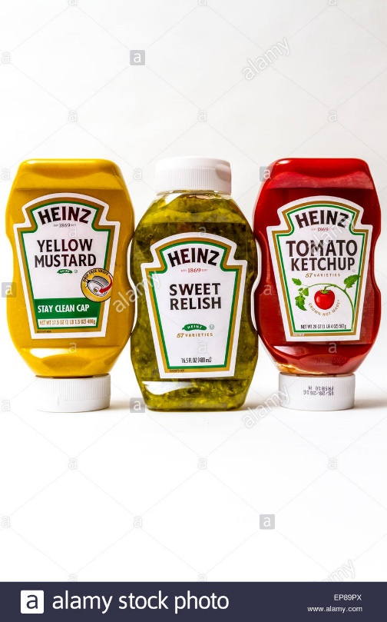](https://www.google.ca/url?sa=i&rct=j&q=&esrc=s&source=images&cd=&cad=rja&uact=8&ved=2ahUKEwjX_9rY6IniAhVqvlkKHWoJC8sQjRx6BAgBEAU&url=https%3A%2F%2Fwww.alamy.com%2Fstock-photo%2Fheinz-ketchup-label.html&psig=AOvVaw1Rs9I5qiz92UxpXSQInEuL&ust=1557332200953552)

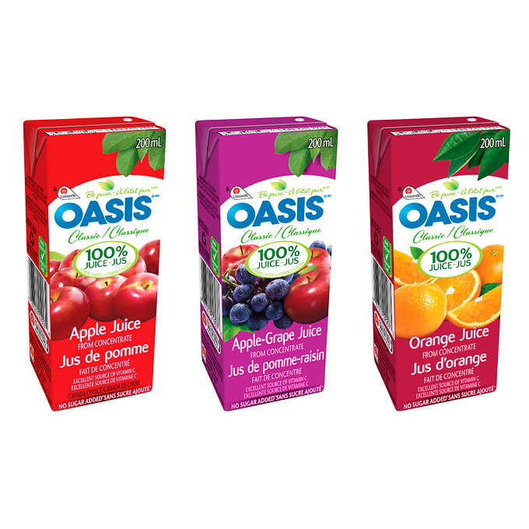

1. Juice - Oasis 100% Juice Assorted Flavours  
   50 × 200 mL